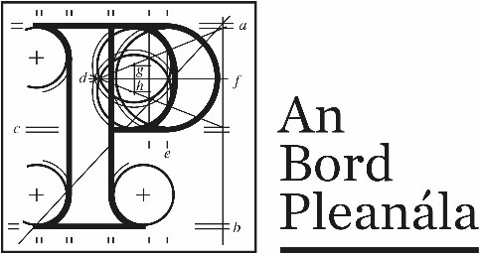 |  | Description of Documents Relating to ABP-320824-24
Proposed development of an IPP compound, including 110kV transformer.
Within the townland of Rosspile, Clongeen, County Wexford.

Letter 1 | Notification letter issued to prospective applicant stating that the proposed development IS NOT SID – 18/12/24
Letter 2 | Notification letter issued to Wexford County Council stating that the proposed development IS NOT SID - 18/12/24

