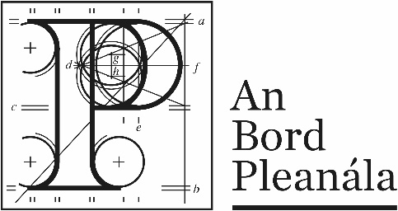 | Description of Documents Relating to ABP-321564-24
A 250MW Data Centre which will source its primary power from a collocated flexible Decentralised Energy Resource (DER). Solid Oxide Fuel Cell Power System, Battery Energy Storage System, Solar PV Installation and Grid connection.
Address: Located in the townlands of Kiltotan & Collinstown, Oldtown & Farthingstown, Co. Westmeath

Record 1 | Record of 1st pre-application consultation meeting held with the prospective applicant on the 12/02/2025
Letter 1 | Notification letter issued to prospective applicant stating that the proposed development IS NOT SID
Letter 2 | Notification letter issued to Westmeath County Council stating that the proposed development IS NOT SID

