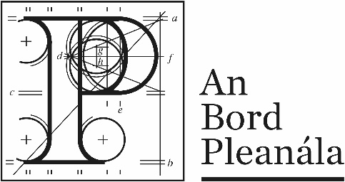 | Board Direction
BD-010693-22
ABP-311036-21

At a meeting held on 12/05/2022, the Board considered the report of the Inspector, and the documents and submissions on file generally, in relation to the proposed development, consisting of the proposed upgrade to the Nenagh Wastewater Treatment Plant in Nenagh, County Tipperary.

The Board decided that proposed development, as set out in the plans and particular received by An Bord Pleanála on the 4th day of August 2021, as amended and added to by the plans and particulars received by the Board on the 7th day of October 2021, does not fall within the scope of section 37A of the Planning and Development Act 2000 (as amended) and that a planning application should therefore be made to the Planning Authority (Tipperary County Council) in the first instance.

Board Member: |  | Date: | 12/05/2022
 | Dave Walsh

