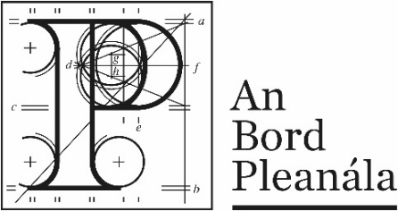 |  |  | Viewing decided case files:  Public Access service  Declaration Form
 | This declaration form is to be completed before a case file can be photocopied or photographed. This does not apply to Inspector’s Report, Board Direction and Board Order.
 | An Bord Pleanála  Case Number(s): |  | Click or tap here to enter text.
Please tick each of the six boxes to confirm that you have read and consent to the following:
- I accept that photocopies or photographs from An Bord Pleanála case file with the above case number, are made available to me under section 146, subsections (5) and (6) of the Planning and Development Act 2000, as amended. They are or may be subject to copyright or related rights.
- I accept that under section 74, Copyright and Related Rights Acts, as amended, material is provided to me by An Bord Pleanála for the purposes of inspection and no other use of the material may be made without the licence of the copyright owner.
- I agree to the conditions set by An Bord Pleanála that I may photograph certain documents on the case file except plans, maps and other documents on which there are copyright restrictions or restrictions placed by An Bord Pleanála.
- I accept not to copy, publish, share, upload, or make public by any means (this includes electronic means such as social media or internet) copies or photographs of documents on the case file provided to me for my personal inspection.
Please turn over to complete boxes 5 and 6 and to fill in your details

- I understand that it is my responsibility under Data Protection legislation to make sure that any personal data contained in any case file which I view is used only for my own personal inspection. I will not use any personal data for any reason except for my own personal inspection. I will not use any personal data in a manner which could cause damage or distress to the subjects of the data.

- I agree that the personal data that I gain access to will not be disclosed to any individual. I will make sure to protect from unauthorised disclosure to any party, any copies of material or notes which I may have during my inspection of the case file. When I no longer require the information in the copies or notes I have, I will dispose of the information in an appropriate manner.

Important notice
You are responsible for any notes, photocopies or photographs taken of documents on a case file. Breaching copyright, data protection and privacy legislation is an offence.

 | Name | Click or tap here to enter text.
 | Contact email or phone | Click or tap here to enter text.
 | Address | Click or tap here to enter text.
 | Signature | Click or tap here to enter text.
 | Date | Click or tap to enter a date.

ver. October 2018

