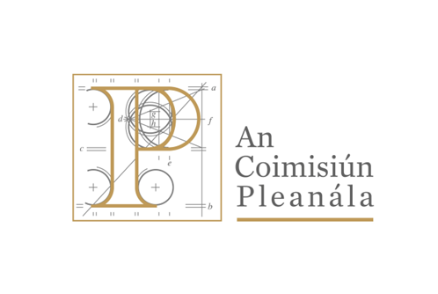

Application Form

SENIOR Planning INspector

An COIMISIÚN pleanála

May 2026

Part 1
- Personal Details
Please complete and return this application form to recruitment@pleanala.ie no later than Friday 29th May 2026 at 3.00 p.m.

Name:
Address:
Contact Details: Home/Mobile No:
E-mail address:
If you will require special facilities at the interview location (e.g. wheelchair access, sign interpreter, braille etc.), please specify special assistance required in the box below:

I hereby declare that I fulfil all the requirements set out for the post of Senior Planning Inspector and that the information given in this form is correct. I give my permission for enquiries to be made to establish such matters as qualifications, experience and character and for the release by other people or organisations of such information as may be necessary for that purpose. This may include enquiries from past/present employers, and the submission of this application is taken as consent to this. I understand that An Coimisiún Pleanála will not contact my current employer without my prior consent.

Please tick this box to authorise An Coimisiún Pleanála expressed permission to use your personal data in relation in this competition, I refer you to point 21-GDPR Privacy Statement in the competition booklet for further information.

Signature: Date:
- Education - 3rd Level/Higher and Professional Qualifications (including courses at present being pursued)
Title of Certificates/, Degree(s)/ Qualification(s) held | Grade(s) (e.g. A, D, H Pass; 2.2; 2.1; 1 etc.) | Course Duration (F/P-time) | School, University, College or Examining Authority | Year of  Award

- Employment - Please provide a short résumé of your professional career to date by completing the following table:
Name/Address of Employer

Title of Post
Start Date  (Month, year) |  | Finish Date  (Month, year)
Brief Description of duties (Max 200 words)

Name/Address of Employer

Title of Post
Start Date  (Month, year) |  | Finish Date  (Month, year)
Brief Description of duties (Max 200 words)

Name/Address of Employer

Title of Post
Start Date  (Month, year) |  | Finish Date  (Month, year)
Brief Description of duties (Max 200 words)

Name/Address of Employer

Title of Post
Start Date  (Month, year) |  | Finish Date  (Month, year)
Brief Description of duties (Max 200 words)

(If you have further relevant experience please include at the end of the form)
- Competitive Irish Language Test (Optional)
You may have your ability to communicate effectively in Irish assessed at a separate competitive language test. This test may comprise conversation on planning topics. In the event that you are rated as being proficient in Irish you will be awarded marks in respect of such proficiency.

I wish to be assessed at a separate competitive language test

Please note that the test for the competitive language will be scheduled for a specific date and the Interview Board will not be in a position to reschedule the time nor date.

Part 2
In order to suitably assess the skills of each candidate a report writing exercise will be conducted prior to the interview stage. This will be a preliminary exercise that will be used to assess Report Writing skills as it is a core element of the role of Senior Planning Inspector. Candidates may be questioned on their report during the interview under the Report Writing and Communication competency.

Part 3
In this section we ask you to give examples from your experience, which would be relevant to the work of a Senior Planning Inspector in An Coimisiún Pleanála. Boxes 1-4 on the following pages correlate to the relevant competencies as set out in the information booklet (Appendix 2). You may include experiences from any kind of setting, for example, education, leisure activities, paid employment, voluntary work, etc. These experiences may be specific incidents or examples of sustained high performance over a sustained period of time.

Compose your replies very carefully having regard to the requirements for the role and try to structure what you write so that you give specific information about what you have done – for example, do not say “X was successful”, describe exactly what you did and why you did it. The information you provide may be used to help structure your interview. Please do not exceed the word count for each competency.

For each of your examples, please include the following:

The nature of the task, problem, situation or objective what you did and how you demonstrated the skill/quality the outcome or result of the situation and your estimate of the proportion of credit you can claim for the outcome.

Please do not use the same example to illustrate your answer to more than one competency. All elements of the application form must be completed in order for your application to be considered.

Please note: If you are called for interview, the interview board will question candidates in relation to the following areas, but not necessarily in the order presented here. Please ensure that you have considered your experiences in each, as the board will be interested in exploring each area thoroughly and systematically in order to build up a picture of your strengths and weaknesses. The Interview board may want to discuss other examples from your experiences, within each skill/quality area, other than the ones you present here.

Before you submit the form to An Coimisiún Pleanála please ensure that you have completed all sections of it and submit it electronically as specified in the Information Booklet.

The onus is on candidates to establish eligibility in this application form. Evidence of qualifications will be required should you be offered a position.

      - Application of Specialist Knowledge and Skills (max 500 words)

2. Organising and Planning of Work (max 500 words)

3. Report Writing and Communication (max 500 words)

4. Initiative and Commitment (max 500 words)

Given the description of the position outlined in the information booklet, we would like you to tell us, in the space provided, what you feel you would bring to the role of Senior Planning Inspector. Please feel free to focus on one or two of your strong points. (max 500 words)

