Visitor information: An Bord Pleanála

**Contents**

Introduction 3

Accessibility 3

Our location 3

Opening hours 4

Travelling to our office 5

Arriving at our office 10

Reception area layout 12

Quiet area 14

Lighting 14

CCTV 14

Language 14

Accessible toilets 15

Baby changing facilities 15

Reception desk 16

Lobby area 17

Maoilbhríde conference room 18

Parnell room 19

Seating area 20

Cathal Brugha room 21

Séan MacDiarmada Room 22

Leaving our office 23

Further information 24

Introduction

Welcome. This guide has been prepared to help you prepare for your visit to An Bord Pleanála.

Accessibility

An Bord Pleanála’s Access Officer is Mark Kielty. If you need to contact Mark or another staff member to help you, please telephone 01 858 8100. You can also contact Mark by email at [accessofficer@pleanala.ie](mailto:accessofficer@pleanala.ie) or at [bord@pleanala.ie](mailto:bord@pleanala.ie). Please contact An Bord Pleanála as soon as possible before your visit if you (or a member of your group) have any access requirements so that we may facilitate you during your visit.

Our location

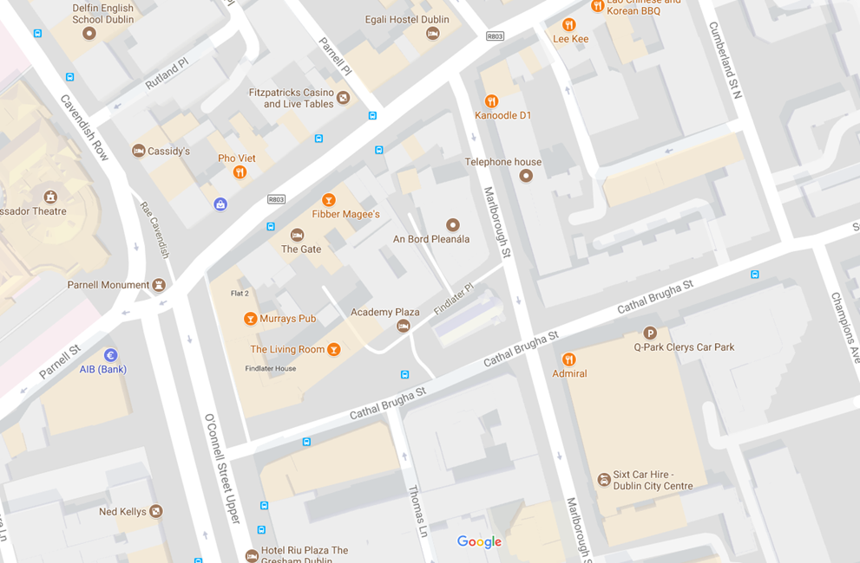We are located in the centre of Dublin at 64 Marlborough Street, D01 V902.

Opening hours

Our normal opening hours are:

|  |  |
| --- | --- |
| Monday | 9.15am – 5.30pm |
| Tuesday | 9.15am – 5.30pm |
| Wednesday | 9.15am – 5.30pm |
| Thursday | 9.15am – 5.30pm |
| Friday | 9.15am – 5.30pm |
| Saturday | Closed |
| Sunday | Closed |
| Public holidays, Good Friday and certain other days | Closed |

We are open throughout the day and we do not close for lunch.

On certain other days when our office is closed, we will notify the public that we are closed. We will also notify the public if we need to amend our opening hours in special circumstances.

However, due to exceptional circumstances this might not always be possible. If you are unsure if our office will be open before you visit, please check our website [www.pleanala.ie](http://www.pleanala.ie), telephone 01 858 8100 or Lo-Call 1800 275 175 before you travel.

Travelling to our office

There are several transport options available to reach our office – bus, bicycle, LUAS, rail and car. An Bord Pleanála is a partner in the Smarter Travel Workplace Programme and supports a sustainable transport policy for staff and customers. We encourage you to use public transport to visit our office.

The [Journey Planner from Transport for Ireland](http://www.journeyplanner.transportforireland.ie/nta/XSLT_TRIP_REQUEST2?language=en) is a comprehensive listing of public transport options and allows you to plan your journey times more accurately from any location in Ireland. The Planner covers bus, rail, tram, taxis, ferries and walking – 120 operators in total – with fully mapped-out route information, printable timetables and details of overall journey times.

The Journey Planner App can be downloaded from [www.transportforireland.ie](http://www.transportforireland.ie)

|  |  |
| --- | --- |
| **Dublin Bus**  [www.dublinbus.ie](http://www.dublinbus.ie) | Dublin Bus stops are near our office on O’Connell Street, Parnell Street, Cathal Brugha Street and other streets. The Dublin Bus website gives the latest details on wheelchair accessible routes, real time bus information and general timetables in Dublin. |
| **Bus Éireann**  [www.buseireann.ie](http://www.buseireann.ie) | Bus Éireann national and regional bus services go to Busáras which is a 10 minutes’ walk from our office. The Bus Éireann website gives timetable, ticket and other information on regional and national bus services. |
| **Other Bus Operators**  [www.transportforieland.ie](http://www.transportforieland.ie) | Other bus operators from around Ireland operate services close to our office. The Transport for Ireland journey planner can help you identify if there is a service near you. |
| **LUAS**  [www.luas.ie](http://www.luas.ie) | LUAS Green Line and Red Line services are available to our office.  On the Green Line services to Broombridge you should take the O’Connell Street Upper stop and walk down Cathal Brugha Street. On the Green Line services to Parnell, Sandyford or Bride’s Glen you should take the Parnell Stop and walk down Marlborough Street.  On Red Line services you should take the Abbey Street stop and walk up Marlborough Street. |

|  |  |
| --- | --- |
| **Iarnród Éireann  Irish Rail**  [www.irishrail.ie](http://www.irishrail.ie) | The main train stations in Dublin City are Connolly and Heuston Stations. Tara Street Station is served by DART and commuter services only.  **Connolly**  An Bord Pleanála’s office is within walking distance of Connolly Station and its national, commuter and DART rail services. Our office is about 10 minutes’ walk from the station or you can get the LUAS (Red Line) to Abbey Street, and walk up Marlborough Street.  **Heuston**  Heuston Station serves national and commuter rail services and is located approximately 2 kilometres from our office. There are Dublin Bus services from Heuston Station to the city centre and the LUAS (Red Line) also runs from Heuston Station to Abbey Street.  Iarnród Éireann - Irish Rail’s website gives full details on rail travel options. |

|  |  |
| --- | --- |
| **Cycling**  [www.dublinbikes.ie](http://www.dublinbikes.ie)  [www.transportforireland.ie](http://www.transportforireland.ie) | A Dublin Bikes station is located on Cathal Brugha Street beside our office, and their website can give the latest availability of bikes and spaces at this and other Dublin Bikes stations.  Bicycle stands are also available on Cathal Brugha Street and routes can be found on the Transport for Ireland Journey Planner.  Estimated cycling times to our office from within the Greater Dublin area are available on [our website](http://www.pleanala.ie/contact/travelmaps.pdf). |
| **Walking** | Estimated walking times to our office within the Dublin area are available on [our website](http://www.pleanala.ie/contact/travelmaps.pdf). |
| **Taxis** | Taxis can be obtained throughout the city and can drop you outside our office at 64 Marlborough Street, Dublin 1, D01 V902. A taxi stand is located nearby on Cathal Brugha Street. |

|  |  |
| --- | --- |
| **Car** | By car, follow one of the main routes (indicated by a N, for example N1, N4, N11) into the city centre and follow the map for directions to our office. There are traffic restrictions and one-way systems in operation across the city centre.  There is an accessible car park space in front of our office, but there is no general on-street parking around our office. Car parks are available nearby. |

Arriving at our office

The entrance to our office is located at 64 Marlborough Street, opposite the Eir building.

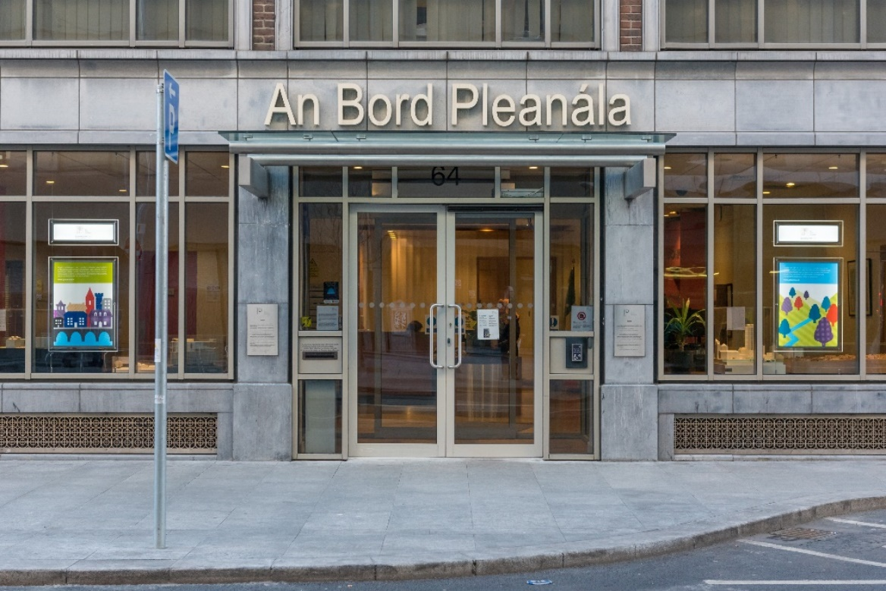

When you arrive at the front door, press the blue button on the intercom.

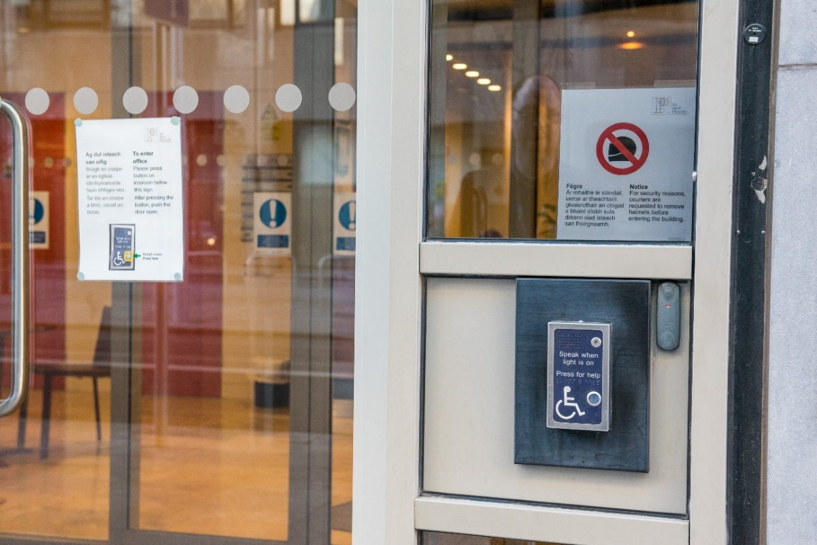

This picture shows the buzzer at the front door of An Bord Pleanála's office. There is a button located half way down the panel on the right hand side. It is located under the Braille text and has a blue light behind it. 

In the image, the button to operate the buzzer has a yellow box around it and a green arrow pointing to it from the right-hand side.

When the buzzer is pressed, a security guard will unlock the door for you or you can ask for assistance. This is a close-up of the buzzer

When you press the buzzer, the door will be unlocked for you by a security guard. The door will automatically open inwards away from you. Once the door is open, you can enter the porch. If you require assistance with the external door please speak into the intercom and a security guard will assist you.

When you enter the porch, there are two doors in front of you which will automatically slide apart when you approach the doors. Walk straight ahead and you are in our reception area.

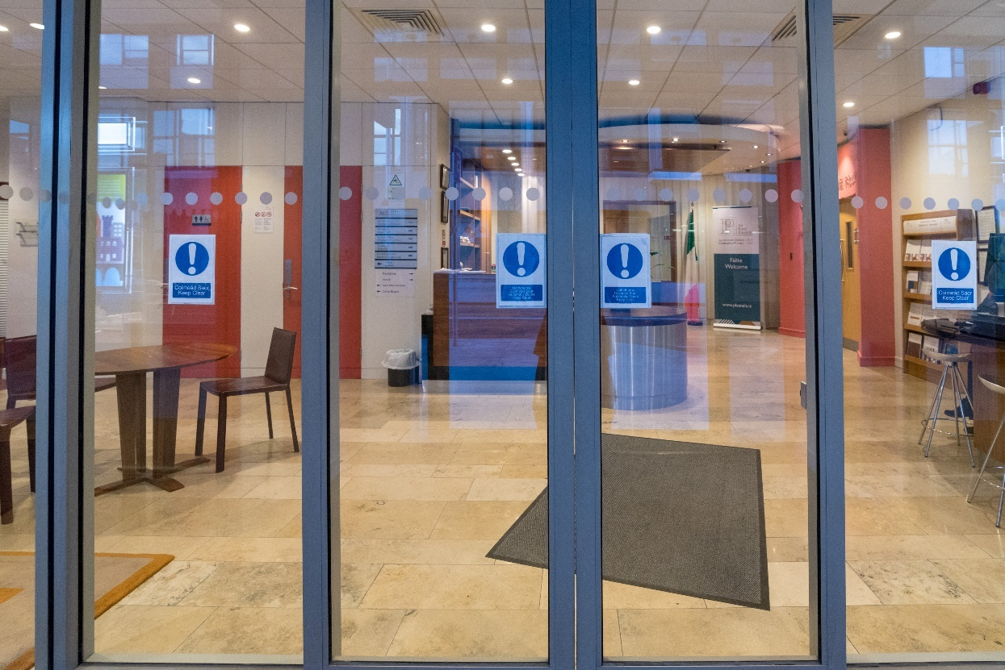

Reception area layout

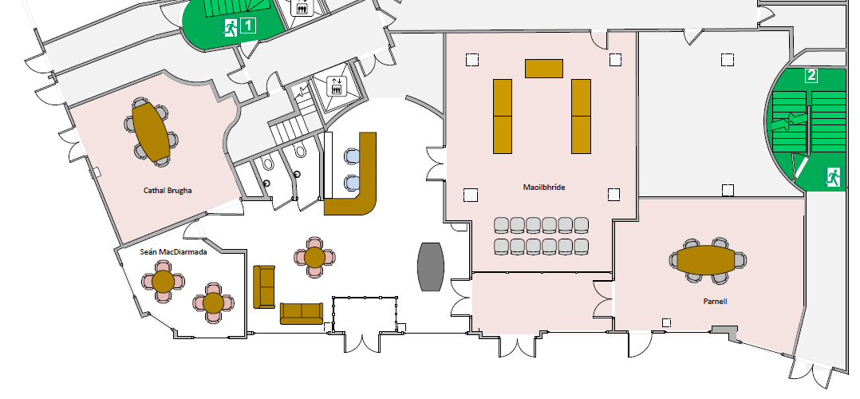This is the layout of the public area of our reception area.

Area open to the public  
 Area closed to the public except during meetings or oral hearings  
🞎 Area closed to the public  
 You are here when you enter the building

When you are standing with the porch sliding doors behind you, the reception desk is in front of you at the 12 o’clock position. The Maoilbhríde conference room, is on the right-hand side at the 2 o’clock position.

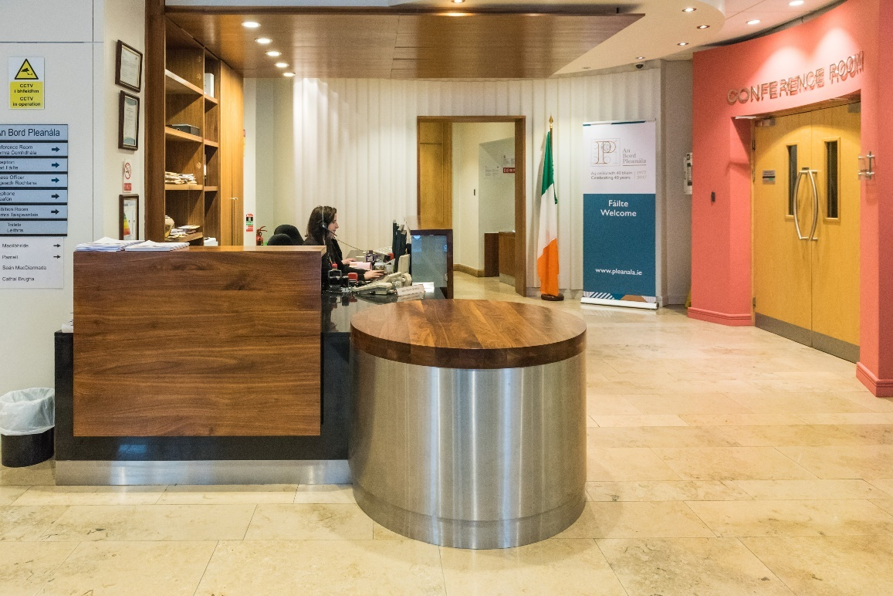

When you are stood with the porch sliding doors behind you, and face to the right-hand side (3 o’clock position), there is the publications stand and there are computers that you can use to access case information. There are 3 computers in total: a computer that is accessible located beside the publications stand, and two computers in the centre stand. There is also the entrance to the Parnell meeting room.

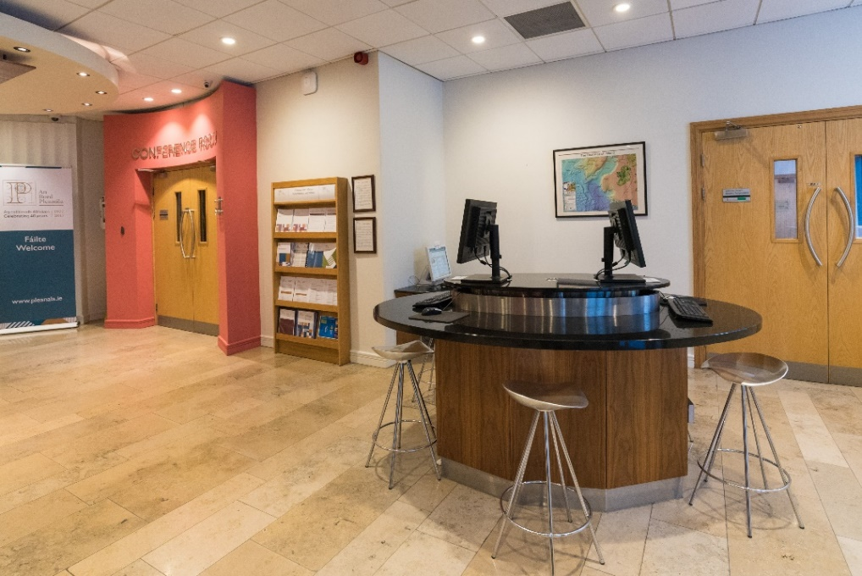

When you are stood with the porch sliding doors behind you, and face to the left-hand side (9 o’clock position), there are the accessible toilets, entrances to the Cathal Brugha and Seán MacDiarmada meeting rooms, seating and tables where you can wait for An Bord Pleanála staff or look at decided files through the public access service.

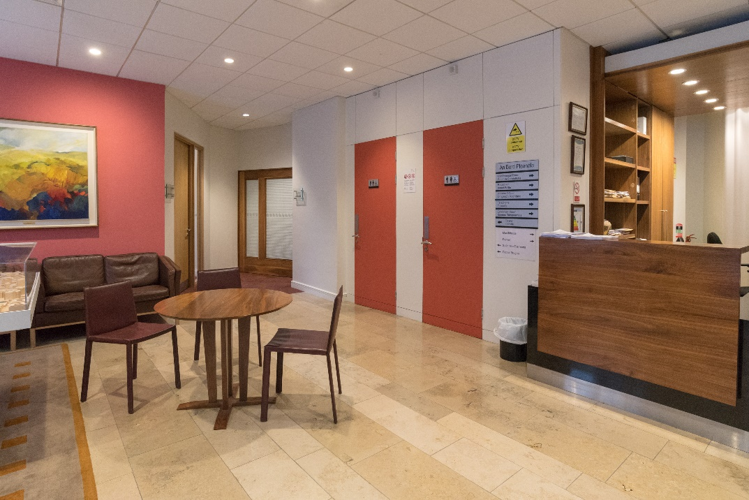

**Assistance, First Aid and other emergencies**

If you require assistance at any point during your visit to An Bord Pleanála, please do not hesitate to speak to one of our staff members or security guards. If you feel unwell at any time, there is First Aid and a defibrillator available in the reception area.

In the event of an emergency, please follow the instructions of the reception staff and security guards and leave by the nearest emergency exit to you. Sometimes an emergency exit may be behind you. Doors which require buzzers are automatically unlocked when the fire alarm is activated. If for any reason the door remains locked, there are release buttons located in green boxes beside the doors. Information regarding evacuations and emergencies is available in the reception area.

**Guide and Assistance Dogs**

Guide and Assistance dogs are welcome and water facilities are available for dogs.

Quiet area

The Seán MacDiarmada room is available for those who require a quieter area.

Lighting

We have natural and artificial lighting in our reception area and meetings room. Lighting may be lowered during presentations and video presentations.

CCTV

Images are recorded in our office for the purpose of crime prevention and for your personal safety. This system is operated by An Bord Pleanála care of Aramark who can be contacted on 01 858 8100.

Language

Customers are welcome to use either English or Irish languages.

Accessible toilets

There are two unisex accessible toilets for customer use. The door to each toilet opens outwards towards the reception area. If there are any issues with the toilets, please notify reception staff.

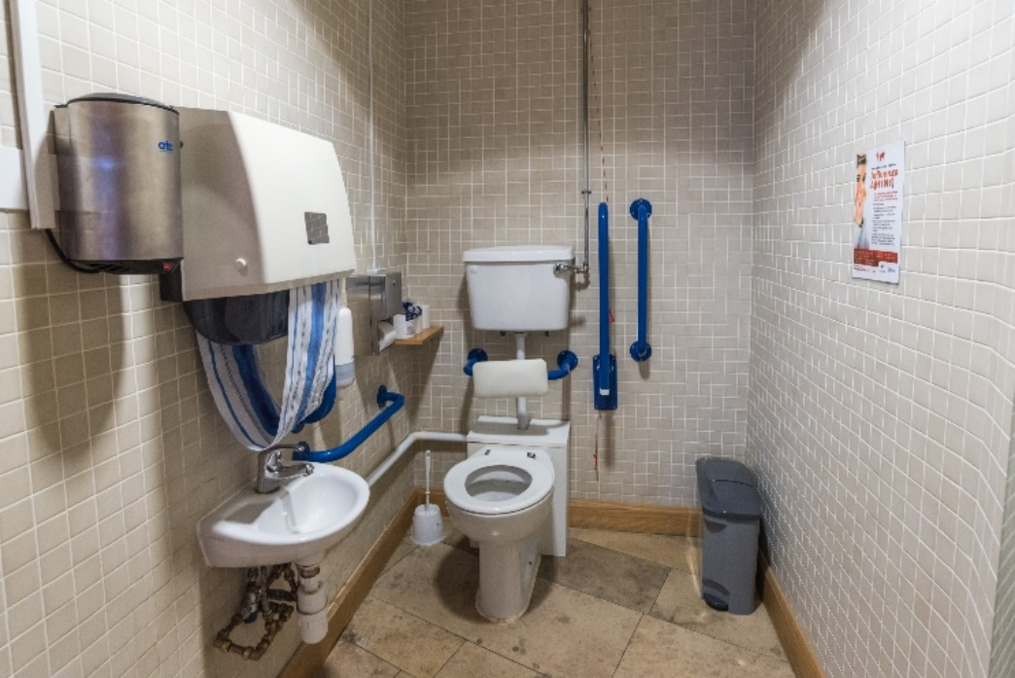

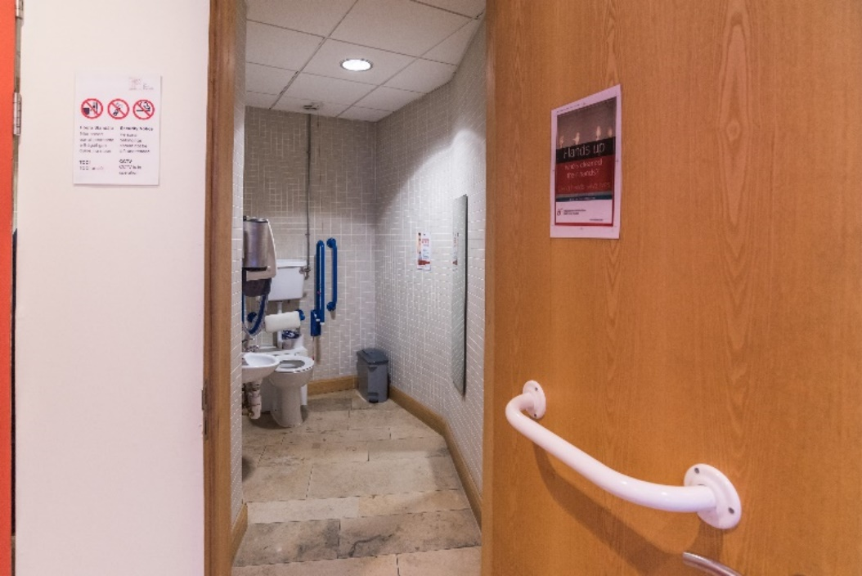

Baby changing facilities

There is a baby changing facility located in the accessible toilet next to the Cathal Brugha Room.

Reception desk

At reception desk, you can:

* Make appeals, applications, referrals and observations.
* Ask to speak to a staff member about a query you have on a case or have documentation checked if making an appeal, application, referral or observation.
* Make a request to view a decided case file.
* Ask to speak to the Access Officer.
* Ask for instructions if you have documents or items to deliver or have an appointment.

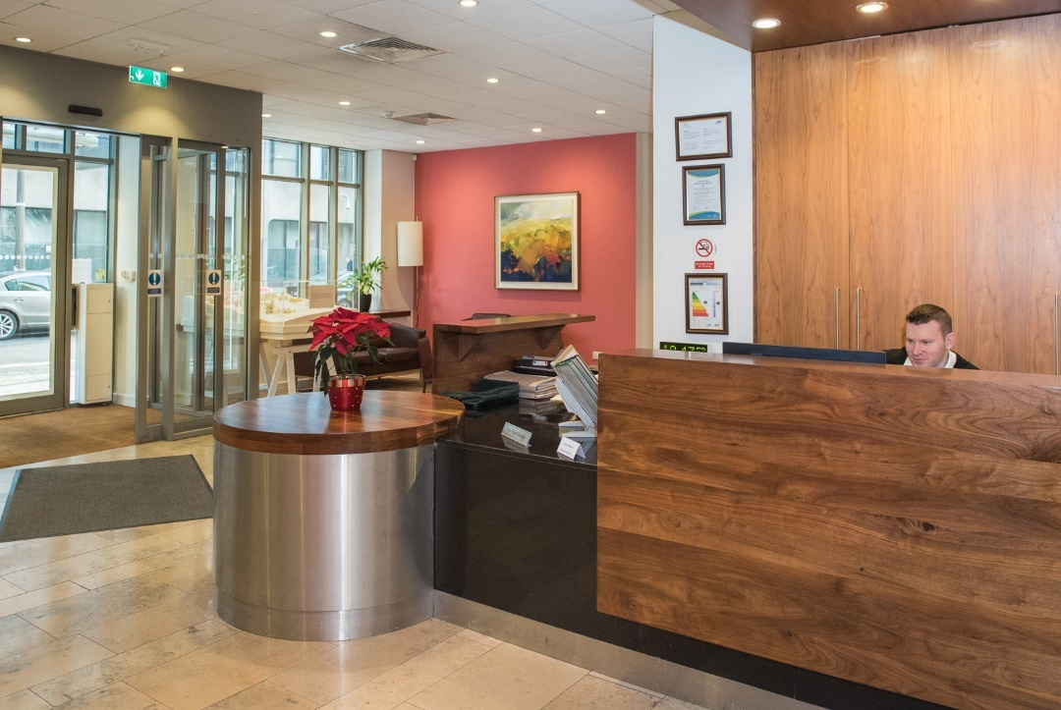

There is always at least one receptionist at the reception desk, and normally there are two receptionists. The desk is accessible for all customers who wish to speak to either receptionist, and a loop system is available for customers who may have problems with hearing.

A defibrillator, first aid and fire extinguishers are available near the reception desk.

Lobby area

In the lobby area there is:

* the information / publications stand with leaflets on topics such as:
  + How to make a planning appeal
  + How to make an observation
  + Fees
  + Corporate documents
* Computer area with three computers for searching planning information and our website. One computer is reserved for members of the public who have accessibility requirements.
* The entrance to the Maoilbhríde Conference room. The Maoilbhríde Conference Room where oral hearings and other meetings are held. This room is not open to the public unless invited or given permission by An Bord Pleanála staff to use.
* The entrance to the Parnell room. The Parnell room where meetings are held. This room is not open to the public unless invited or given permission by An Bord Pleanála staff to use.

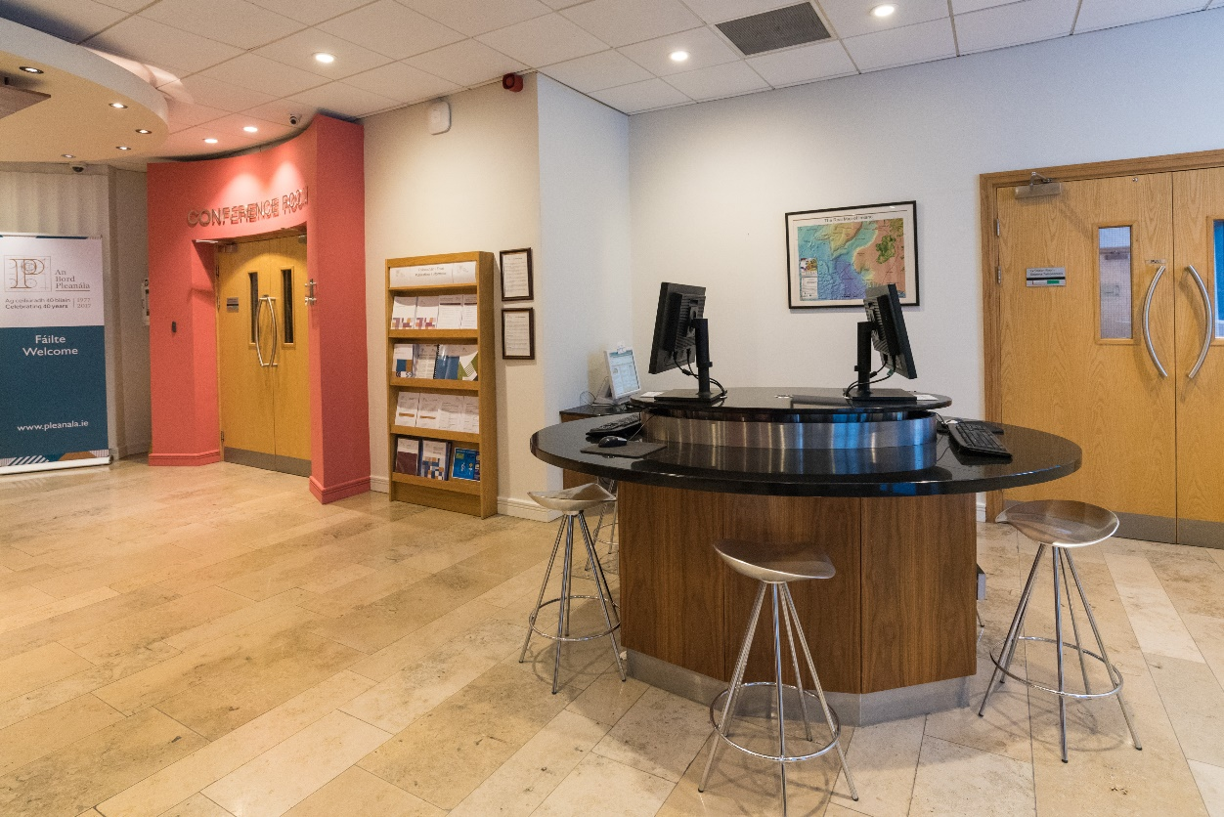

Maoilbhríde conference room

* This room is not open to the public unless invited to attend an event such as a meeting or oral hearing, or if you have been given permission by An Bord Pleanála staff to use.
* If you are attending an event in this room, you will need to be given access by an An Bord Pleanála staff member or security guards.
* If you are speaking at an event and wish to use a presentation or other display please contact the person who has invited you to the event or email [bord@pleanala.ie](mailto:bord@pleanala.ie).
* The Maoilbhríde conference room has a podium that is height adjustable and accessible to all.
* On leaving the room, at the door you will need to press a buzzer located on the right-hand side to unlock the doors. When unlocked walk straight ahead and you will be at the reception desk.
* Staff will guide you in the event of an emergency.

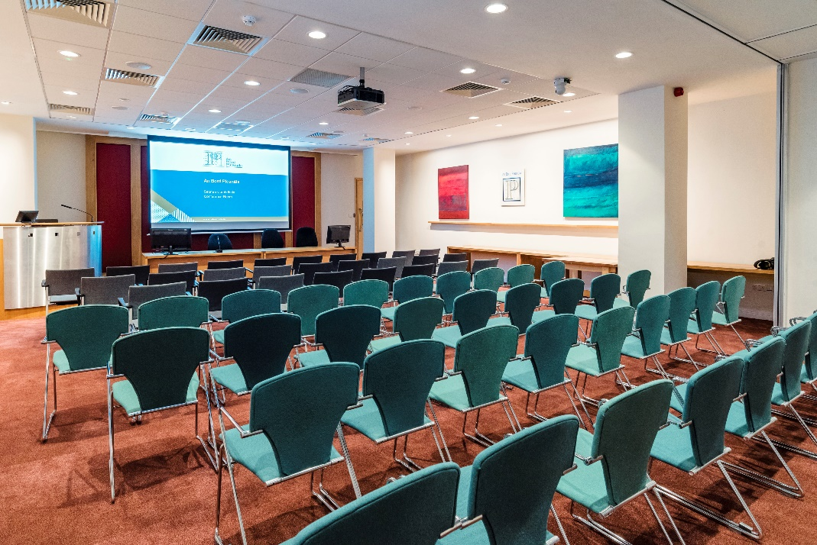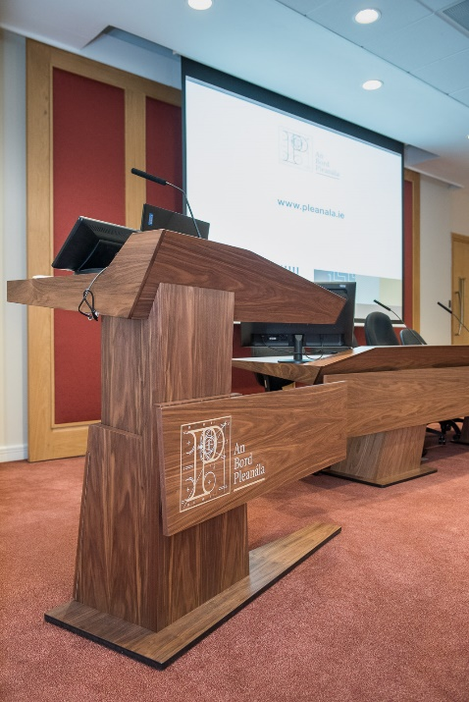

Parnell room

* This room is not open to the public unless invited or given permission by An Bord Pleanála staff to use.
* If you are attending an event in this room, you will need to be given access by a member of An Bord Pleanála staff or security guards. When you enter the room, there is gentle ramp going upwards immediately. The ramp area is indicated by yellow floor tiles.
* On leaving the room the gentle ramp goes downwards towards the doors. The ramp area is indicated by yellow floor tiles.
* At the door you will need to press a buzzer located on the left-hand side to unlock the doors. Walk straight ahead to the next set of doors. Here you will need to press another buzzer to unlock the doors. You will then be in the lobby area of reception.
* Staff will guide you in the event of an emergency.

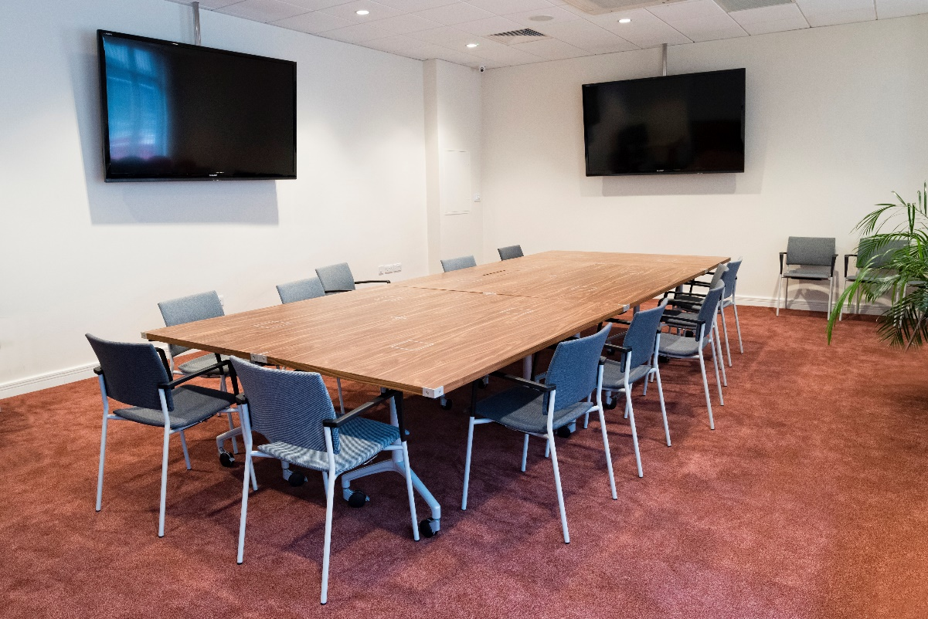

Seating area

* Seating area where you can wait for An Bord Pleanála staff.
* Models of current and recently decided cases may be on display.
* Table and chairs where you can sit and check documents you are going to give to An Bord Pleanála.
* You can also use the table and chairs to look at cases you have requested through our public access to cases service.

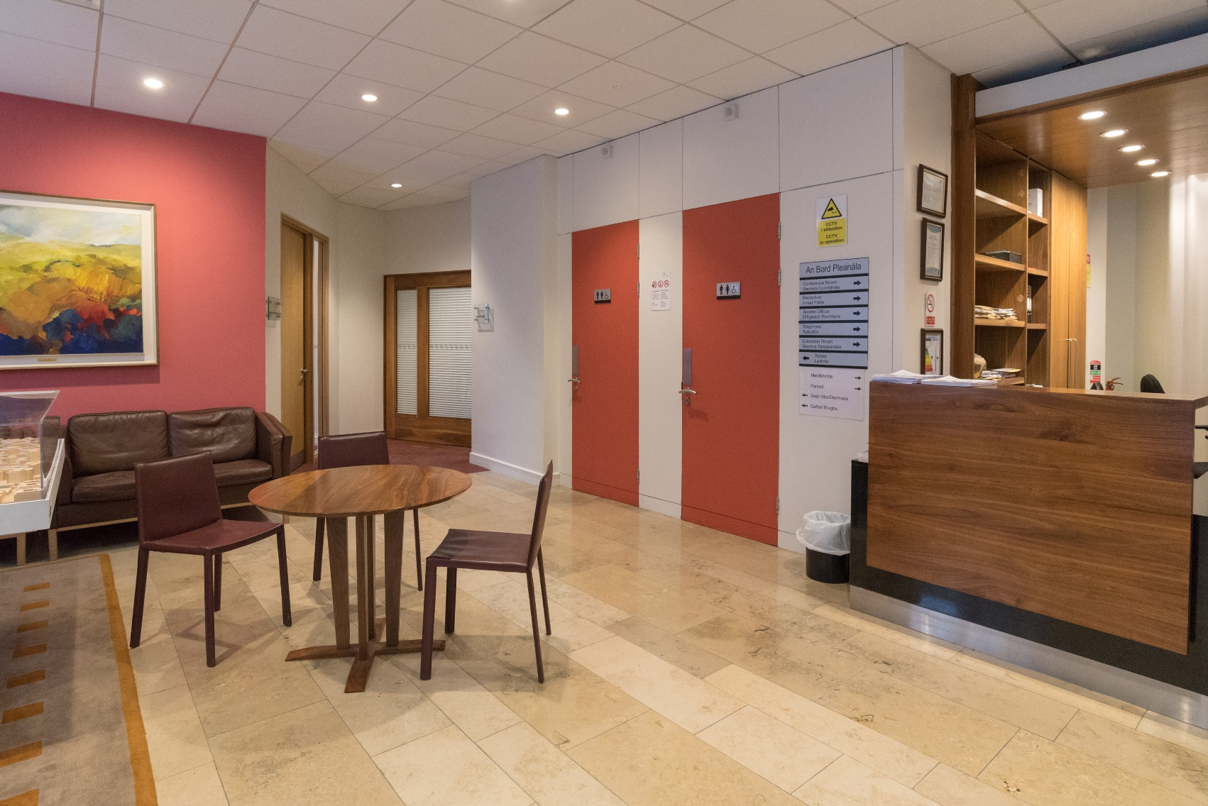

Cathal Brugha room

* This room is not open to the public unless invited to attend an event or given permission by An Bord Pleanála staff to use.
* If attending an event in the Cathal Brugha room the door to this room swings open. To enter you need to pull the door towards reception and enter through the widest part of the opening. To exit you need to push the door towards the reception and leave through the widest part of the opening.
* Staff will guide you in the event of an emergency.

This image shows the Cathal Brugha room and the swinging door to either enter or exit the room. 

To enter you need to pull the door towards reception and enter through the widest part of the opening. To exit you need to push the door towards the reception and leave through the widest part of the opening. 

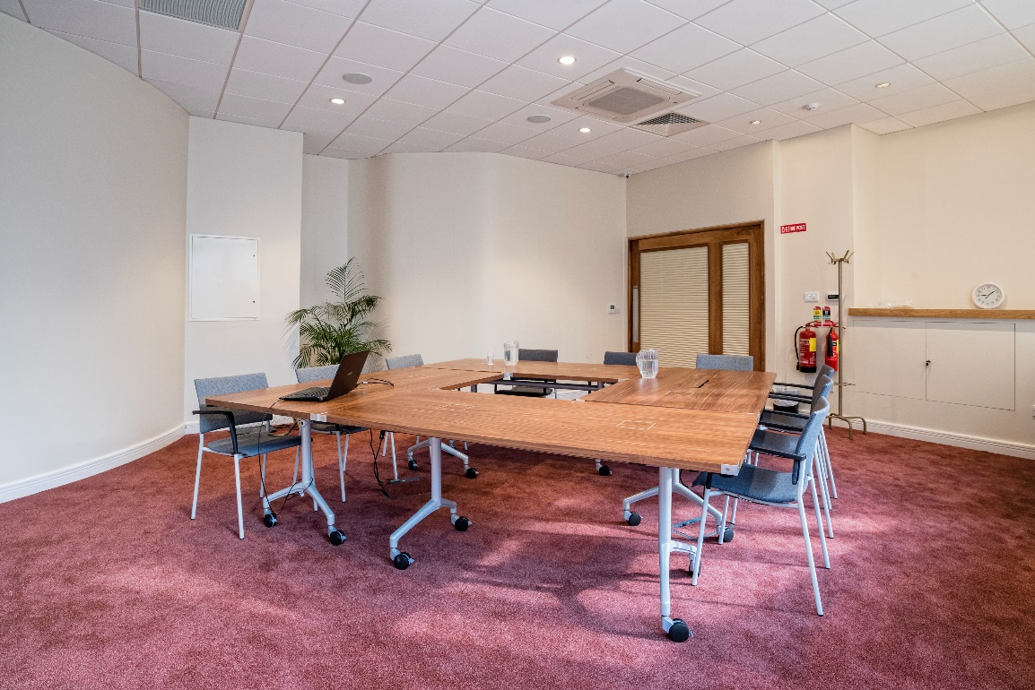

Séan MacDiarmada Room

This room is normally available for the general public to use and you do not require permission to use it if the door is open. This room is quiet and has natural light. In this room you can:

* Wait for An Bord Pleanála staff in a more relaxed area
* Discuss planning matters in private with staff
* Look at cases requested through the public access to decided cases service.

In the event of an emergency, you should leave the room and proceed to the reception area and follow staff members or security guards’ instructions.

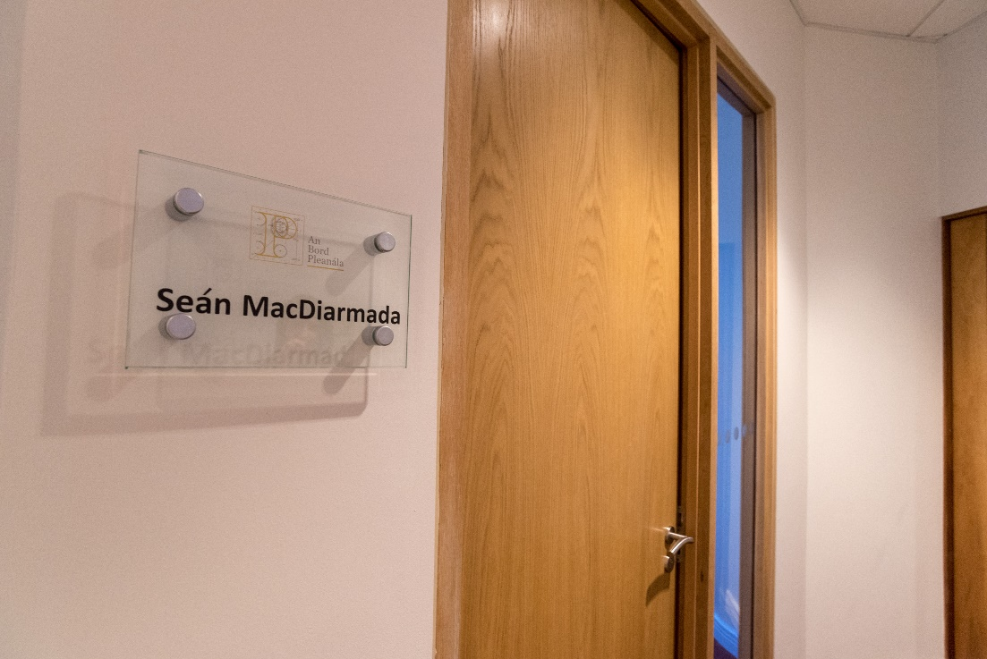

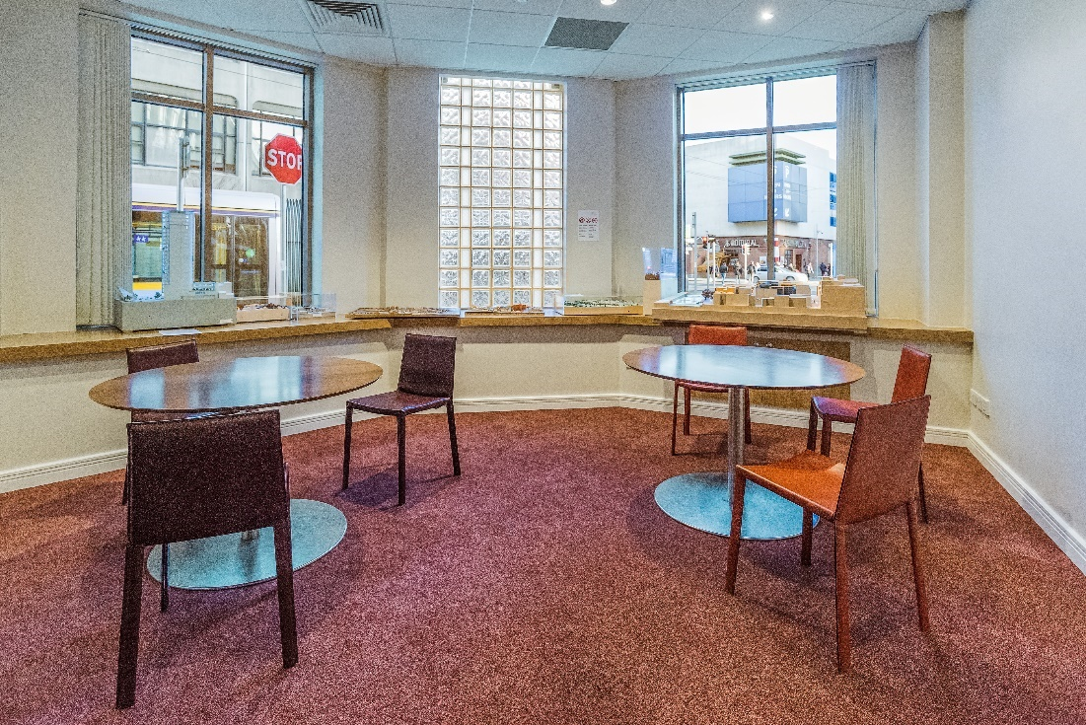

Leaving our office

When you have finished your visit to An Bord Pleanála, you leave through the same doors you entered the building on Marlborough Street.

The porch doors will automatically slide apart when you approach them.

As you walk through the porch, the external door onto Marlborough Street should automatically open for you as you walk towards the door. The door will open inwards towards you. You will then exit onto Marlborough Street in front of the Eir building. If you want to go to Cathal Brugha Street, Talbot Street or O’Connell Street you need to turn right. If you want to go to Parnell Street, you need to turn left.

If the door will not open this is because the sensor has been unable to see you. To exit, please take a few steps back towards the reception area and then approach the doors again. The door should now open for you.

This image shows the external door open button for exiting onto the street if assistance with opening the door is required. Assistance can also be sought from staff or security staff.

This image also shows the button highlighted by a yellow box and a green arrow pointing to the yellow box.If you require assistance with the external door there is a green button located on the porch door frame that will open the external door for you. Alternatively, you can ask the receptionist or security guard for further assistance.

Further information

We have tried to make this guide as accurate as possible. However, An Bord Pleanála will not be held responsible for any action arising out of its use.

If you require this document in an alternative format or for further information, please contact An Bord Pleanála by:

|  |  |
| --- | --- |
| Visiting our offices at: | **An Bord Pleanála 64 Marlborough Street  Dublin 1  D01 V902** |
| Writing to us at: |
| Telephoning us on: | (01) 858 8100 or LoCall: 1800 275 175 |
| Emailing us at: | [bord@pleanala.ie](mailto:bord@pleanala.ie) |
| Visiting our website: | [www.pleanala.ie](http://www.pleanala.ie) |
| Sending us a fax on: | (01) 872 2684 |

This edition: April 2020.