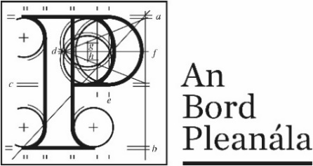 | Leave to Appeal  Application Form

Your details
 | 1. | Applicant’s details (person applying for leave to appeal)  Your full details:
 |  | (a) | Name | Click or tap here to enter text.
 |  | (b) | Address | Click or tap here to enter text.

Agent’s details
 | 2. | Agent’s details (if applicable)  If an agent is acting for you on this Leave to Appeal application, please also provide their details below. If you are not using an agent, please write “Not applicable” below.
 |  | (a) | Agent’s name | Click or tap here to enter text.
 |  | (b) | Agent’s address | Click or tap here to enter text.
Postal address for letters
 | 3. | During the application, we will post information and items to you or to your agent. For this application, who should we write to? (Please tick one box only.)
 |  | You (the applicant) at the address in Part 1 |  | The agent at the address in Part 2 | ☐
Details about the proposed development
 | 4. | Please provide details about the planning authority decision you wish to make a Leave to Appeal application. If you want, you can include a copy of the planning authority’s decision as the details.
 | (a) | Planning authority  (for example: Ballytown City Council)
 |  | Click or tap here to enter text.
 | (b) | Planning authority register reference number  (for example: 18/0123)
 |  | Click or tap here to enter text.
 | (c) | Location of proposed development  (for example: 1 Main Street, Baile Fearainn, Co Ballytown)
 |  | Click or tap here to enter text.

Your interest in the land adjoining the proposed development site
 | 5. | Please provide details about your interest in the land which is adjoining (next to or joined with) the proposed development site.

Application details
 | 6. | Grounds
 |  | Please describe the grounds on which you want to make a Leave to Appeal application (planning reasons and arguments). You can type or write them in the space below or you can attach them separately.

Supporting material
 | 7. | If you wish, you can include supporting materials with your application. Supporting materials include:  - photographs,  - plans,  - surveys,  - drawings or maps.
Fee
 | 8. | You must make sure that the correct fee is included with your application.  You can find out the correct fee to include in our Fees and Charges Guide on our website.

The National Adult Literacy Agency (NALA)
has awarded this document its Plain English Mark.
Last updated: July 2020.

