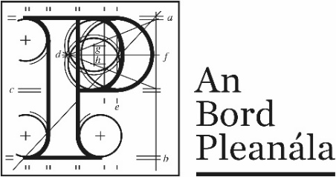
Building Control Acts:
Appeal Form

Type of appeal
 | 1. | Type of appeal  Please tick () the box which applies to what decision you want to appeal
 |  | ☐ | Fire safety certificate | ☐ | Dispensation
 |  | ☐ | Revised fire safety certificate | ☐ | Disability access certificate
 |  | ☐ | Regularisation | ☐ | Revised disability access certificate
 |  | ☐ | Relaxation

Your details
 | 2. | Appellant’s details (person making the appeal)  Your full details:
 |  | (a) | Name | Click or tap here to enter text.
 |  | (b) | Address | Click or tap here to enter text.

Agent’s details
 | 3. | Agent’s details (if applicable)  If an agent is making your appeal, please provide their details below. If you are not using an agent, please write “Not applicable” below.
 |  | (a) | Agent’s name | Click or tap here to enter text.
 |  | (b) | Agent’s address | Click or tap here to enter text.

Postal address for letters
 | 4. | During the appeal we will post information and items to you or to your agent. For this appeal, who should we write to? (Please tick one box only)
 |  | You (the appellant) at the address in Part 2 | ☐ |  | The agent at the address in Part 3 | ☐

Details about the decision you want to appeal

 | 5. | Please provide details about the building control authority decision you wish to appeal. If you want, you can include a copy of the building control authority’s decision as the appeal details.
 | (a) | Building control authority  (for example: Ballytown City Council)
 |  | Click or tap here to enter text.
 | (b) | Building control authority register reference number  (for example: FSC18/0123)
 |  | Click or tap here to enter text.
 | (c) | Location  (for example: 1 Main Street, Baile Fearainn, Co Ballytown)
 |  | Click or tap here to enter text.

Appeal details

 | 6. | Please describe the grounds of your appeal. You can type or write them in the space below or you can attach them separately.

Supporting materials

 | 7. | If you wish you can include supporting materials with your appeal. Supporting materials include:  - photographs,  - plans,  - surveys,  - drawings,  - digital videos or DVDs,  - technical guidance, or  - other supporting materials.

Fee

 | 8. | You must make sure that the correct fee of €500 is included with your appeal.

