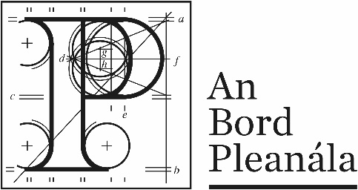 | Request for Access to Records under the Freedom of Information Act 2004
The following record come withing the scope of the Act:
- All records relation to personal information held by An Bord Pleanála irrespective of when created.
- All other records created from the 21st April 1998.
- Any other records necessary to the understanding of a current record.
The Act does not apply to records already publicly available. For example, an appeal determined by An Bord Pleanála, is available for purchase / inspection under An Bord Pleanála’s public access system - please ask at reception.

Details of Applicant

Name | Click or tap here to enter text.
Postal Address | Click or tap here to enter text.
Email | Click or tap here to enter text.
Mobile Telephone Number | Click or tap here to enter text.
Home or Business Telephone Number | Click or tap here to enter text.
Personal Information
Before you are given access to personal information relating to yourself, you may be asked to provide proof of your identity.

Office Use Only
Identify Verified ☐ Consent Confirmed ☐
Staff member  signature: |  | Date: | Click or tap here to enter date.

Details of Request
In accordance with section 12 of the Freedom of Information Act, I request access to records which are: (please tick as appropriate)
Personal | ☐ | Non-personal | ☐

In the space provided please describe the record as fully as you can. If you are requesting personal information, state precisely in whose name those records are held. You will not normally be given access to personal information of another person unless you have obtained the written consent of that person. An Bord Pleanála will verify this consent.

I request the following records:
Click or tap here to enter text.

Form of access
My preferred form of access is: (please tick as appropriate)
To receive copies of the records by post | ☐
To view the records at An Bord Pleanála’s offices | ☐
Other (please specify on the line below | ☐
Click or tap here to enter text.

Fee (if required)
Please see below table of fees, and attach appropriate fee with your request if required.

Please sign your name and today’s date on the line below:
Signature: | Click or tap here to enter signature.
Date: | Click or tap here to enter date.

Fees relating to Freedom of Information Requests / Applications
(Effective from Tuesday 14th October 2014.)
Type of Request / Application | Standard Fee* | Reduced Fee* & ** & ***
Request for a Record under Section 12
Initial Request | No Charge | No Charge
Internal Appeal | €30 | €10
Appeal to Information Commissioner | €50 | €15
Request under section 12 for personal information
Request under section 12 for personal information | No Charge | No Charge
Application under section 9 for amendment of a record containing incorrect, incomplete or misleading personal information
Application under section 9 for amendment of a record containing incorrect, incomplete or misleading personal information | No Charge | No Charge
Application under section 10 for the reasons for a decision affecting the individual
Application under section 10 for the reasons for a decision affecting the individual | No Charge | No Charge

* Fee will not apply where a person appeals a decision to charge a fee or deposit, or a fee or deposit of a particular amount under section 27 of the FOI Act.
** Reduced fee will apply in respect of third parties who appeal a decision of a public body to release their information on public interest grounds.
*** Reduced fee will apply to medical card holders and their dependants on production of their medical card.

