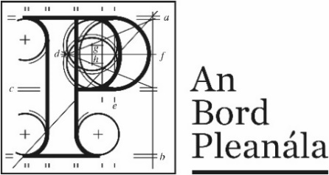 | Planning Appeal Form  (After receiving Leave to Appeal)

Your details
 | 1. | Appellant’s details (person making the appeal)  Your full details:
 |  | (a) | Name | Click or tap here to enter text.
 |  | (b) | Address | Click or tap here to enter text.

Agent’s details
 | 2. | Agent’s details (if applicable)  If an agent is acting for you on this appeal, please also provide their details below. If you are not using an agent, please write “Not applicable” below.
 |  | (a) | Agent’s name | Click or tap here to enter text.
 |  | (b) | Agent’s address | Click or tap here to enter text.
Postal address for letters
 | 3. | During the appeal, we will post information and items to you or to your agent. For this appeal, who should we write to? (Please tick one box only.)
 |  | You (the appellant) at the address in Part 1 | ☐ | The agent at the address in Part 2 | ☐

Details about the proposed development
 | 4. | Please provide the An Bord Pleanála Leave to Appeal case number. You can also provide details of the planning authority decision you wish to appeal. If you want, you can include a copy of An Bord Pleanála’s or the planning authority’s decision as the appeal details.
 | (a) | An Bord Pleanála Leave to Appeal case number  (for example: ABP-300000-20)
 |  | Click or tap here to enter text.
 | (b) | Planning authority  (for example: Ballytown City Council)
 |  | Click or tap here to enter text.
 | (c) | Planning authority register reference number  (for example: 18/0123)
 |  | Click or tap here to enter text.
 | (d) | Location of proposed development  (for example: 1 Main Street, Baile Fearainn, Co Ballytown)
 |  | Click or tap here to enter text.

Appeal details
 | 5. | Grounds
 |  | Please describe the grounds of your appeal (planning reasons and arguments). You can type or write them in the space below, or you can attach them separately.

Supporting material
 | 6. | If you wish, you can include supporting materials with your appeal. Supporting materials include:  - photographs,  - plans,  - surveys,  - drawings,  - digital videos or DVDs,  - technical guidance, or  - other supporting materials.

Fee
 | 7. | You must make sure that the correct fee is included with your appeal.  You can find out the correct fee to include in our Fees and Charges Guide on our website.

Oral hearing request
 | 8. | If you wish to request the Board to hold an oral hearing on your appeal, please tick the “Yes, I wish to request an oral hearing” box below.  Please note you will have to pay an additional non-refundable fee of €50. You can find information on how to make this request on our website or by contacting us.  If you do not wish to request an oral hearing, please tick the “No, I do not wish to request an oral hearing” box.
 |  | Yes, I wish to request an oral hearing | ☐
 |  | No, I do not wish to request an oral hearing | ☐

The National Adult Literacy Agency (NALA)
has awarded this document its Plain English Mark.
Last updated: July 2020.

