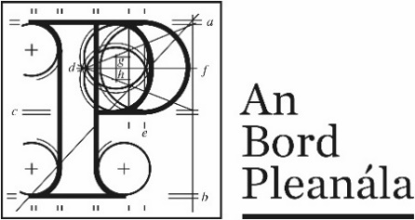 | Planning Appeal Form

Your details
 | 1. | Appellant’s details (person making the appeal)  Your full details:
 |  | (a) | Name | Click or tap here to enter text.
 |  | (b) | Address | Click or tap here to enter text.

Agent’s details
 | 2. | Agent’s details (if applicable)  If an agent is acting for you, please also provide their details below. If you are not using an agent, please write “Not applicable” below.
 |  | (a) | Agent’s name | Click or tap here to enter text.
 |  | (b) | Agent’s address | Click or tap here to enter text.

Postal address for letters
 | 3. | During the appeal we will post information and items to you or to your agent. For this appeal, who should we write to? (Please tick one box only.)
 |  | You (the appellant) at the address in Part 1 | ☐ | The agent at the address in Part 2 | ☐
Details about the proposed development
 | 4. | Please provide details about the planning authority decision you wish to appeal. If you want, you can include a copy of the planning authority’s decision as the appeal details.
 | (a) | Planning authority  (for example: Ballytown City Council)
 |  | Click or tap here to enter text.
 | (b) | Planning authority register reference number  (for example: 18/0123)
 |  | Click or tap here to enter text.
 | (c) | Location of proposed development  (for example: 1 Main Street, Baile Fearainn, Co Ballytown)
 |  | Click or tap here to enter text.

Appeal details
 | 5. | Please describe the grounds of your appeal (planning reasons and arguments). You can type or write them in the space below or you can attach them separately.

Supporting material
 | 6. | If you wish you can include supporting materials with your appeal. Supporting materials include:  - photographs,  - plans,  - surveys,  - drawings,  - digital videos or DVDs,  - technical guidance, or  - other supporting materials.

Acknowledgement from planning authority
(third party appeals)
 | 7. | If you are making a third party appeal, you must include the acknowledgment document that the planning authority gave to you to confirm you made a submission to it.

Fee
 | 8. | You must make sure that the correct fee is included with your appeal.  You can find out the correct fee to include in our Fees and Charges Guide on our website.

Oral hearing request
 | 9. | If you wish to request the Board to hold an oral hearing on your appeal, please tick the “yes, I wish to request an oral hearing” box below.  Please note you will have to pay an additional non-refundable fee of €50. You can find information on how to make this request on our website or by contacting us.  If you do not wish to request an oral hearing, please tick the “No, I do not wish to request an oral hearing” box.
 |  | Yes, I wish to request an oral hearing | ☐
 |  | No, I do not wish to request an oral hearing | ☐

NALA has awarded this document its Plain English Mark
Last updated: April 2019.

